**--Q1: Who is the senior most employee based on job title?**

SELECT title, last_name, first_name

FROM employee

ORDER BY levels DESC

LIMIT 1

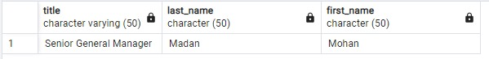

**--Q2: Which countries have the most Invoices?**

SELECT COUNT(*) AS c, billing_country

FROM invoice

GROUP BY billing_country

ORDER BY c DESC

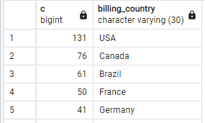

**--Q3: What are top 3 values of total invoice?**

SELECT ROUND(total::NUMERIC,2) AS total

FROM invoice

ORDER BY total DESC

LIMIT 3

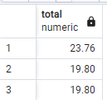

**/*Q4: Which city has the best customers? We would like to throw a promotional**

**Music Festival in the city we made the most money.**

**Write a query that returns one city that has the highest sum of invoice totals.**

**Return both the city name & sum of all invoice totals */**

SELECT billing_city, ROUND(SUM(total)::NUMERIC,2) AS InvoiceTotal

FROM invoice

GROUP BY billing_city

ORDER BY InvoiceTotal DESC

LIMIT 1;

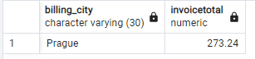

**/*Q5: Who is the best customer? The customer who has spent the most money**

**will be declared the best customer.**

**Write a query that returns the person who has spent the most money.?*/**

**SELECT customer.customer_id, first_name, last_name, ROUND(SUM(total) :: NUMERIC,2) AS total_spending**

**FROM customer**

**JOIN invoice ON customer.customer_id = invoice.customer_id**

**GROUP BY customer.customer_id**

**ORDER BY total_spending DESC**

**LIMIT 1;**

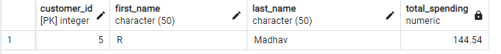

**/*Q6: Write query to return the email, first name, last name, &**

**Genre of all Rock Music listeners.**

**Return your list ordered alphabetically by email starting with A. */**

SELECT DISTINCT email AS Email,first_name AS FirstName, last_name AS

LastName, genre.name AS Name

FROM customer

JOIN invoice ON invoice.customer_id = customer.customer_id

JOIN invoice_line ON invoice_line.invoice_id = invoice.invoice_id

JOIN track ON track.track_id = invoice_line.track_id

JOIN genre ON genre.genre_id = track.genre_id

WHERE genre.name LIKE 'Rock'

ORDER BY email;

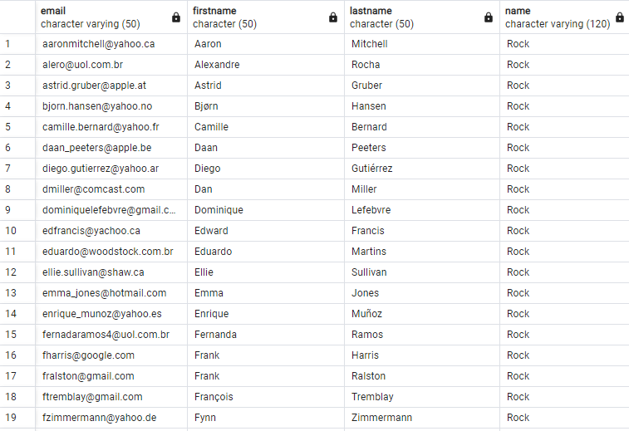

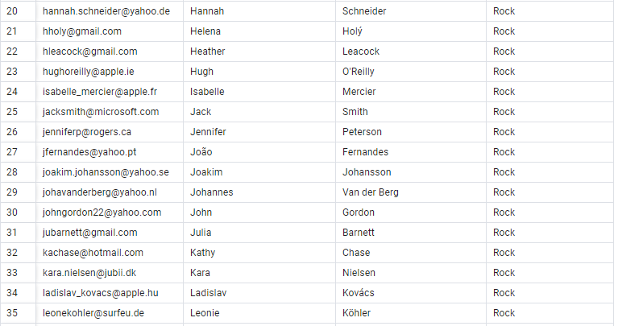

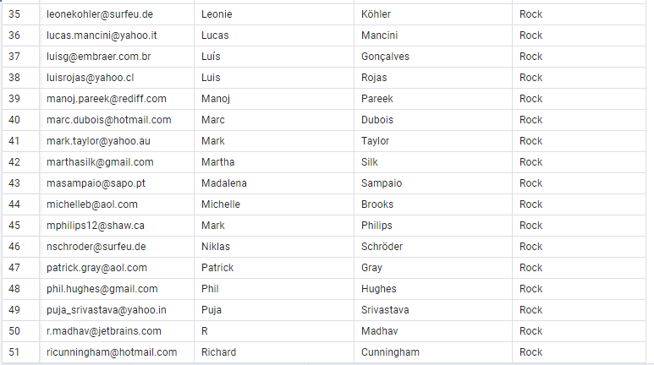

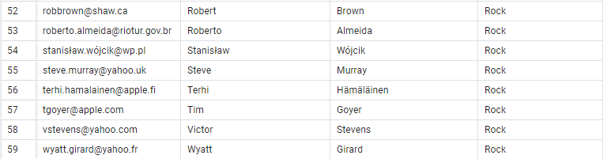

**/*Q7: Let's invite the artists who have written the most rock music**

**in our dataset.**

**Write a query that returns the Artist name and total track count of**

**the top 10 rock bands.*/**

SELECT artist.artist_id, artist.name,COUNT(artist.artist_id) AS number_of_songs

FROM track

JOIN album ON album.album_id = track.album_id

JOIN artist ON artist.artist_id = album.artist_id

JOIN genre ON genre.genre_id = track.genre_id

WHERE genre.name LIKE 'Rock'

GROUP BY artist.artist_id

ORDER BY number_of_songs DESC

LIMIT 10;

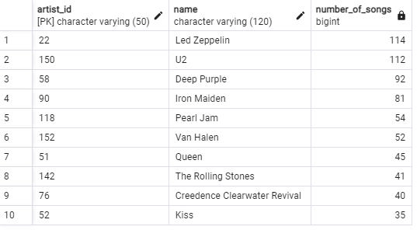

**/*Q8: Return all the track names that have a song length longer**

**than the average song length.**

**Return the Name and Milliseconds for each track. Order by the song**

**length with the longest songs listed first. */**

SELECT name,milliseconds

FROM track

WHERE milliseconds > (

SELECT AVG(milliseconds) AS avg_track_length

FROM track )

ORDER BY milliseconds DESC

**/*Q9: Find how much amount spent by each customer on artists?**

**Write a query to return customer name, artist name and total spent */**

WITH best_selling_artist AS (

SELECT artist.artist_id AS artist_id, artist.name AS artist_name, SUM(invoice_line.unit_price*invoice_line.quantity) AS total_sales

FROM invoice_line

JOIN track ON track.track_id = invoice_line.track_id

JOIN album ON album.album_id = track.album_id

JOIN artist ON artist.artist_id = album.artist_id

GROUP BY 1

ORDER BY 3 DESC

LIMIT 1

)

SELECT c.customer_id, c.first_name, c.last_name, bsa.artist_name,

SUM(il.unit_price*il.quantity) AS amount_spent

FROM invoice i

JOIN customer c ON c.customer_id = i.customer_id

JOIN invoice_line il ON il.invoice_id = i.invoice_id

JOIN track t ON t.track_id = il.track_id

JOIN album alb ON alb.album_id = t.album_id

JOIN best_selling_artist bsa ON bsa.artist_id = alb.artist_id

GROUP BY 1,2,3,4

ORDER BY 5 DESC;

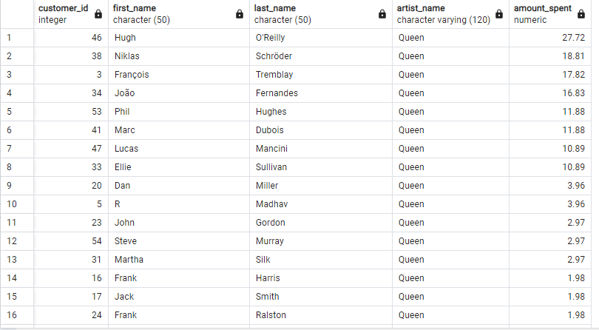

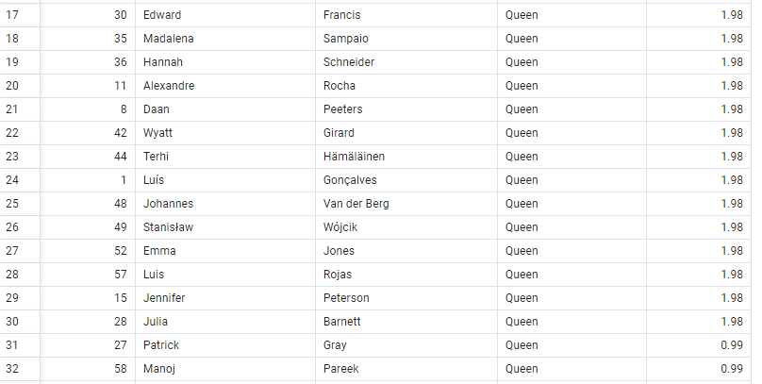

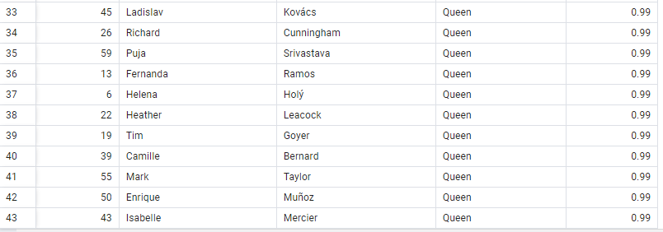

**/*Q10: We want to find out the most popular music Genre for each country.**

**We determine the most popular genre as the genre with the highest amount**

**of purchases. Write a query that returns each country along with the top**

**Genre. For countries where the maximum number of purchases is shared return**

**all Genres.*/**

WITH popular_genre AS

(

SELECT COUNT(invoice_line.quantity) AS purchases, customer.country, genre.name, genre.genre_id,

ROW_NUMBER() OVER(PARTITION BY customer.country ORDER BY COUNT(invoice_line.quantity) DESC) AS RowNo

FROM invoice_line

JOIN invoice ON invoice.invoice_id = invoice_line.invoice_id

JOIN customer ON customer.customer_id = invoice.customer_id

JOIN track ON track.track_id = invoice_line.track_id

JOIN genre ON genre.genre_id = track.genre_id

GROUP BY 2,3,4

ORDER BY 2 ASC, 1 DESC

)

SELECT * FROM popular_genre WHERE RowNo <= 1

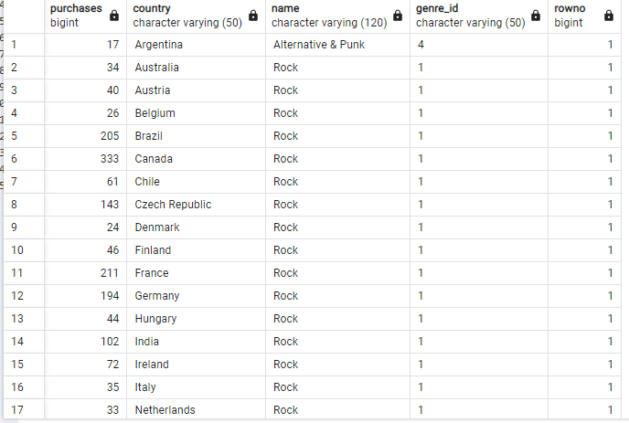

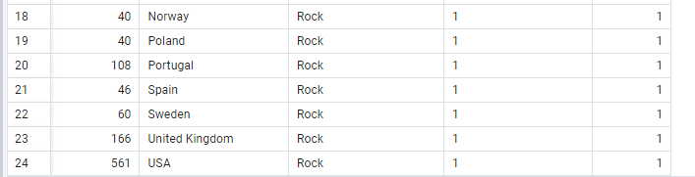

**/*Q11: Write a query that determines the customer that has spent the most**

**on music for each country. Write a query that returns the country along**

**with the top customer and how much they spent. For countries where the**

**top amount spent is shared, provide all customers who spent this amount. */**

WITH Customter_with_country AS (

SELECT customer.customer_id,first_name,last_name,billing_country, Round(SUM(total)::numeric,2) AS total_spending,

ROW_NUMBER() OVER(PARTITION BY billing_country ORDER BY SUM(total) DESC) AS RowNo

FROM invoice

JOIN customer ON customer.customer_id = invoice.customer_id

GROUP BY 1,2,3,4

ORDER BY 4 ASC,5 DESC)

SELECT * FROM Customter_with_country WHERE RowNo <= 1

